**Flask API**

Code:

1. Check if python is already installed. Type ‘python’ to check.
2. In command window or Windows PowerShell (Administrator mode)—

**PS C:\Python25> mkdir newproj**

**PS C:\Python25> cd newproj**

**C:\Python25\newproj>py -m venv env**

**C:\Python25\newproj>env\Scripts\activate**

**(env) C:\Python25\newproj>pip install flask**

**(env) C:\Python25\newproj>python hello.py**

1. Python file for API:

**#hello.py**

**from flask import Flask**

**app = Flask(__name__)**

**@app.route("/")**

**def hello_world():**

**return "Hello, Apurva!"**

**app.run()**

Implementation:

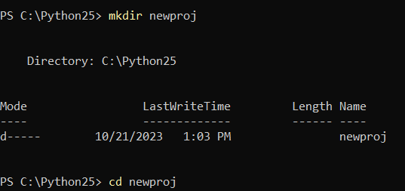

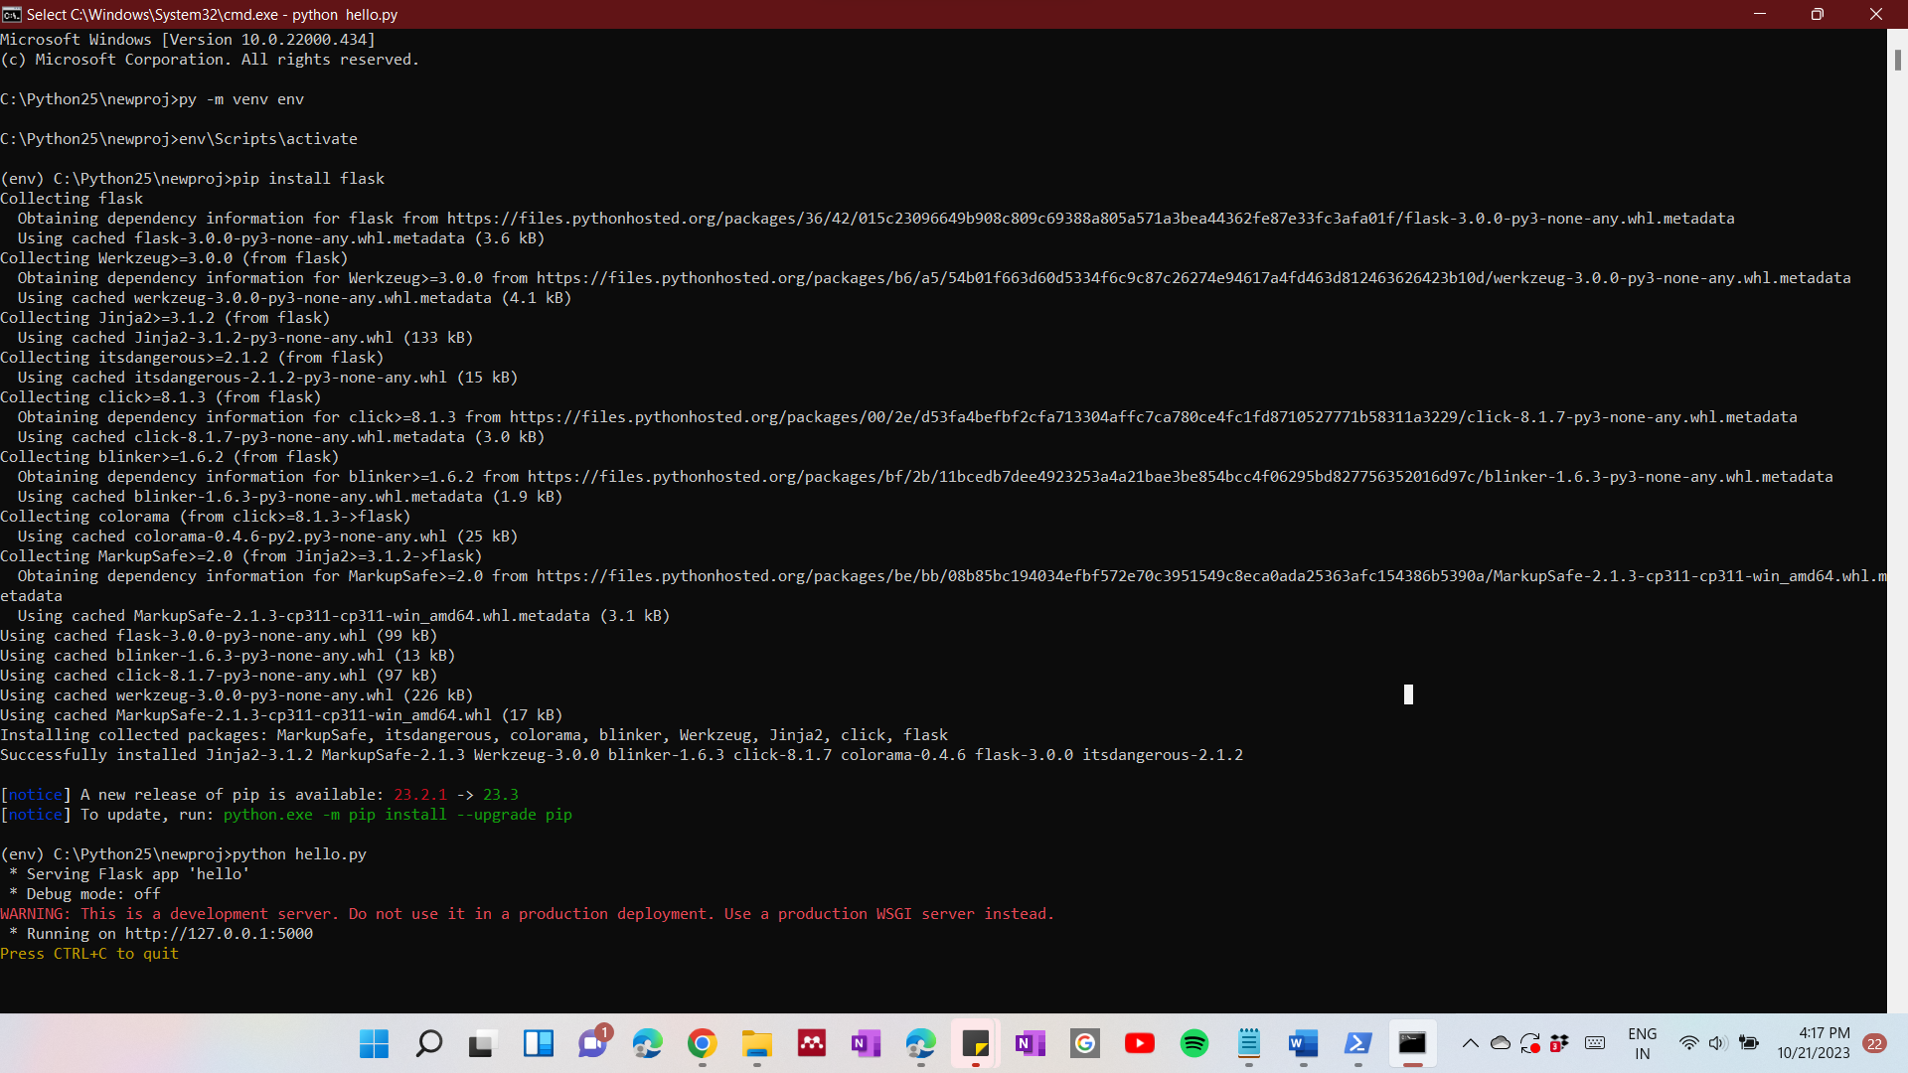

Output:

